PROPOSED METHODOLOGY FOR AFC
One-Month Blended AI Training, Practical Application and Post-Implementation Support
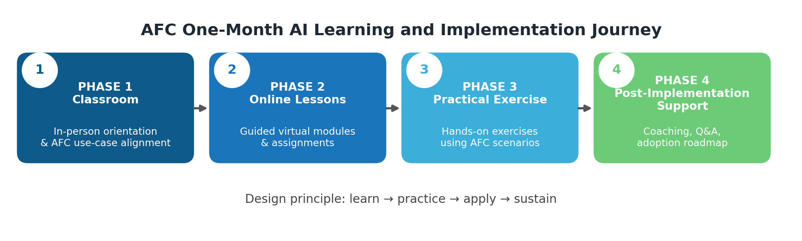

1. Approach Overview
AI Institute Africa, in partnership with Rubiem Intelligence and the University of Zimbabwe, will adopt a practical, executive-focused and impact-driven methodology designed for immediate applicability within AFC's operating environment. The updated approach is structured as a one-month blended programme that moves participants from classroom learning to online reinforcement, practical exercises and post-implementation support.
Our methodology is structured around four connected phases:
• Phase 1: Classroom training and needs alignment
• Phase 2: Online lessons and guided assignments
• Phase 3: Practical exercises using AFC-relevant scenarios
• Phase 4: Post-implementation support, reporting and adoption roadmap
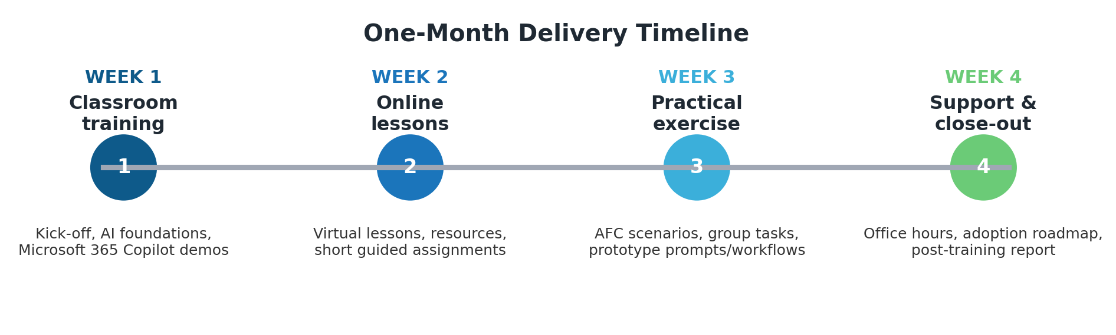

2. One-Month Delivery Timeframe
Week | Phase | Delivery Mode | Primary Outputs
Week 1 | Phase 1: Classroom | In-person, facilitator-led | Aligned agenda, AI foundations, AFC use-case priorities
Week 2 | Phase 2: Online Lessons | Virtual lessons and digital resources | Recorded/live sessions, guided assignments, knowledge checks
Week 3 | Phase 3: Practical Exercise | Hands-on practical lab | Group exercises, AI prompts, workflow prototypes, practical demonstrations
Week 4 | Phase 4: Support | Office hours and advisory support | Implementation Q&A, post-training report, adoption roadmap

3. Phase 1: Classroom Training and AFC Needs Alignment
During the first week, we will engage AFC stakeholders and deliver an in-person classroom programme that establishes a common executive understanding of AI and identifies priority AFC use cases.
• Align training content with AFC strategic priorities and operational challenges
• Identify key executive roles, decision-making contexts and productivity bottlenecks
• Introduce AI, machine learning, generative AI and responsible AI governance
• Demonstrate Microsoft 365 Copilot applications for Word, Excel, PowerPoint, Outlook and Teams
• Customize examples around investment analysis, document drafting, reporting, stakeholder communication and operational efficiency

Outputs:
• Tailored AFC training agenda
• Priority AFC use-case list
• Context-specific case studies and classroom materials

4. Phase 2: Online Lessons and Guided Reinforcement
In week two, participants will complete online lessons that reinforce the classroom content and support flexible learning without disrupting executive schedules.
• Short virtual lessons covering AI productivity, prompt design and executive decision support
• Guided assignments that allow participants to apply lessons to everyday AFC work products
• Digital resources, templates and practical AI use-case guides
• Knowledge checks to confirm understanding and identify areas requiring additional coaching

Outputs:
• Online lesson completion record
• Participant assignment submissions
• Refined prompts and productivity templates

5. Phase 3: Practical Exercise and Applied Demonstrations
In week three, the programme moves from theory to application through practical exercises. Participants will work through AFC-relevant scenarios and build confidence using AI tools in a controlled environment.
• Scenario-based group exercises using AFC-relevant documents, reports and communication tasks
• Hands-on use of AI tools for summarization, analysis, drafting, presentation generation and meeting preparation
• Live facilitation to help participants improve prompts, validate outputs and manage risks
• Demonstrations of how practical AI workflows can support productivity and decision-making

Outputs:
• Completed practical exercises
• Reusable AI workflow examples
• Participant feedback on use-case feasibility

6. Phase 4: Post-Implementation Support and Sustainability
In week four, we will support implementation through advisory office hours, follow-up guidance and a concise close-out report. This ensures the programme leads to sustained adoption rather than a once-off training event.
• Post-training Q&A and advisory support sessions
• Review of participant challenges and recommended mitigations
• Guidance on governance, ethics, data protection and responsible AI adoption
• Final report summarizing insights, training outcomes and recommended next steps for AFC

Outputs:
• Post-training report
• Recommendations for AFC AI adoption
• One-page adoption roadmap and support plan

7. Training Materials and Resources
Participants will receive practical materials that can be reused after the training programme:
• Executive-level slide decks
• AI productivity and Microsoft 365 Copilot use-case guides
• Prompt templates and workflow checklists
• Reference materials and toolkits
• Certificates of completion

8. Delivery Method
• Blended delivery model: classroom, online lessons, practical exercises and post-implementation support
• Interactive facilitator-led sessions supported by digital tools and live demonstrations
• A one-month structure that allows learning, application and support to happen in a managed sequence

9. Value Addition
Our partnership brings together complementary strengths that support AFC's objectives:
• Academic rigor from the University of Zimbabwe
• Industry expertise from Rubiem Intelligence
• Specialized AI training capability from AI Institute Africa
• A practical methodology designed to create measurable adoption and immediate productivity gains

